

Advance visual programming
Lab Report

Submitted by :
Momna Rab Nawaz
232201021
Submitted to:
Sir Uzair Hassan

Dated:26-03-26

Practical Report: AI-Based Mini Project in .NET
Chatbot

1. Project Introduction
- Problem Statement: Students often need a quick, accessible way to query information or get study assistance without leaving their development environment.
- Objective: To design and implement a desktop-based "KICSIT AI Assistant" using .NET 8.0 and the Google Gemini API to provide real-time conversational support.

2. System Design
- Architecture: The application utilizes a Client-Server architecture. The Windows Forms (WinForms) interface acts as the client, sending requests to the Google Gemini cloud-based LLM (Server).
- Workflow: 1. User enters a prompt into the text field. 2. The application securely retrieves the API key and sends an asynchronous request to the Gemini-2.5-flash-lite model. 3. The API processes the natural language and returns a structured response. 4. The response is parsed and displayed in the chat window.

3. Tools & Technologies
- Framework: .NET 8.0 (Long Term Support).
- Language: C# (WinForms).
- Library: Google.GenAI SDK (v2.5.0).
- API: Google Gemini API (Model: gemini-2.5-flash-lite).

4. Code Snippets
Asynchronous API Integration:
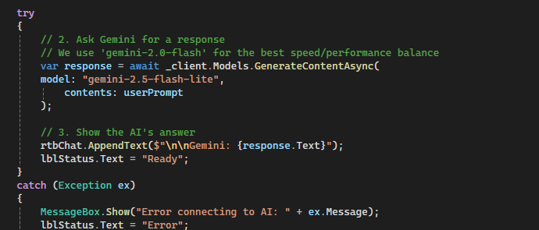
- Explanation: Using await ensures the UI remains responsive (does not "freeze") while waiting for the AI to generate a response.

5. Application Preview
- User Interface: Features a clean, minimalist design with a history window, status labels (e.g., "Ready"), and an "Ask Gemini" action button.
- Working Process: The screenshot demonstrates the bot successfully identifying the user as a "Kicsit Student" and providing a relevant, helpful greeting.
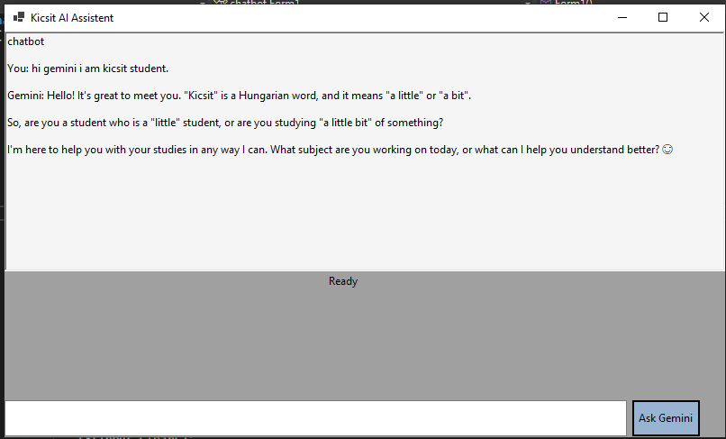

6. Testing
- Sample Input: "hi gemini i am kicsit student."
- Sample Output: "Hello! It's great to meet you. 'Kicsit' is a Hungarian word... I'm here to help you with your studies in any way I can."

7. Results & Discussion
- What Worked Well: The integration of the Google.GenAI NuGet package was straightforward, and the asynchronous task handling provided a smooth user experience.
- Limitations & Challenges: * Quota Limits: During development, a "429 Resource Exhausted" error occurred because the free tier quota for certain models was set to zero.
  - Model Compatibility: Encountered "unexpected model name format" errors when using older model versions, which required updating to the current gemini-2.5-flash-lite version.

8. Docker Requirement
- Base Image: mcr.microsoft.com/dotnet/sdk:8.0 – used for compiling the code.
- Build Process: The Dockerfile performs a dotnet restore to fetch dependencies and a dotnet publish to create the final executable.
- Run Command: ENTRYPOINT ["dotnet", "chatbot.dll"] – the command used to start the application inside the container.

